Smart Grid Optimization Using Machine Learning: Enhancing Efficiency, Stability, And Predictive Maintenance

Dr.R.Lavanya  
Department of Computing Technologies *SRM Institute of Science and Technologies*  
Kattankulathur,Chennai, India  
lavanyar@srmist.edu.in

Jani K G  
Department of Computing Technologies *SRM Institute of Science and Technologies*  
Kattankulathur,Chennai, India  
jg4119@srmist.edu.in

Juloori Yoshitha  
Department of Computing Technologies *SRM Institute of Science and Technologies*Kattankulathur,Chennai, Indiajs1330@srmist.edu.in

*Abstract*— The advancement of smart grid technologies offers a transformative approach to managing and optimizing electrical grids. This project explores the application of machine learning techniques to enhance the efficiency, stability, and predictive maintenance of smart grids. By leveraging various machine learning models, such as supervised learning, unsupervised learning, and reinforcement learning, the project aims to address critical challenges in grid management. Key areas of focus include real-time load forecasting, anomaly detection, and predictive maintenance scheduling.

The integration of machine learning algorithms facilitates more accurate load predictions, thereby optimizing energy distribution and reducing operational costs. Additionally, anomaly detection models identify and mitigate potential disruptions before they impact the grid, enhancing overall system stability. Predictive maintenance approaches are employed to forecast equipment failures, allowing for timely interventions and minimizing downtime.

The project utilizes a combination of historical grid data, real-time sensor inputs, and simulation results to train and validate the machine learning models. The outcomes of this research are expected to contribute to more resilient and efficient smart grid operations, supporting the transition towards a more sustainable and reliable energy infrastructure.

Keywords—machine learning, predictive maintenance, unsupervised learning, reinforcement learning, load forecasting.

# Introduction

The modern electrical grid, known as the smart grid, represents a significant advancement over traditional grid systems, incorporating digital communication and control technologies to improve efficiency and reliability. As the demand for electricity continues to grow and renewable energy sources become more prevalent, the need for advanced grid management solutions has never been more critical. The complexity of modern smart grids requires sophisticated methods to optimize performance, ensure stability, and manage maintenance effectively. Machine learning, with its ability to analyse large datasets and identify patterns, offers a promising approach to addressing these challenges.

Machine learning techniques can enhance grid efficiency by providing accurate load forecasts and optimizing energy distribution in real-time. By analysing historical data and real-time sensor inputs, machine learning models can predict energy consumption patterns, enabling grid operators to adjust supply dynamically and reduce operational costs. Additionally, machine learning algorithms can detect anomalies and potential failures within the grid infrastructure before they escalate into significant issues. This capability is crucial for maintaining grid stability and preventing outages, which can have far-reaching impacts on both consumers and the broader economy.

Predictive maintenance, facilitated by machine learning, further enhances the smart grid's reliability by forecasting equipment failures and scheduling timely interventions. This proactive approach reduces downtime and extends the lifespan of critical infrastructure components. Through the integration of machine learning into smart grid management, this project aims to develop innovative solutions that enhance operational efficiency, ensure system stability, and support a sustainable and resilient energy infrastructure. By leveraging advanced algorithms and real-time data, the project seeks to pave the way for smarter, more adaptive grid systems that meet the evolving needs of modern energy demands

# LITERATURE SURVEY

Authors in [1] provide an overview of various machine learning techniques applied to smart grid management. The study covers algorithms like neural networks, support vector machines, and clustering methods, focusing on their applications in load forecasting, anomaly detection, and grid optimization. In article [2], the authors explore recent advancements in predictive maintenance for electrical grids, emphasizing the application of machine learning models for forecasting equipment failures, discussing model performance, feature selection, and implementation challenges. Article [3] investigates machine learning techniques for real-time load forecasting in smart grids, evaluating different algorithms, including deep learning and ensemble methods, and their effectiveness in predicting energy demand and optimizing grid performance. The authors in [4] examine deep learning approaches for anomaly detection in smart grids, reviewing various architectures such as autoencoders and recurrent neural networks (RNNs) and their performance in identifying potential disruptions and maintaining grid stability. Article [5] focuses on optimizing energy distribution using machine learning algorithms, highlighting the use of reinforcement learning and optimization techniques to enhance the efficiency of energy distribution systems in smart grids. In [6], authors explore machine learning methods for analyzing and enhancing grid stability, discussing various algorithms and their applications in detecting stability issues and implementing corrective measures in smart grid systems. The study in [7] addresses the challenges of integrating renewable energy sources into smart grids using machine learning, covering techniques for managing variability and ensuring efficient energy distribution while incorporating renewable sources. Article [8] presents a comparative analysis of different predictive models for grid maintenance, examining various machine learning approaches, including regression models and ensemble methods, and their effectiveness in forecasting maintenance needs. The authors in [9] discuss the application of machine learning for optimizing smart grid efficiency, reviewing optimization techniques and their impact on reducing operational costs and improving overall grid performance. Finally, article [10] focuses on developing real-time anomaly detection and response systems for smart grids using machine learning, highlighting the challenges and solutions for implementing these systems in practice, with a focus on improving grid reliability and resilience.

.

III SYSTEM IMPLEMENTATION.

## Training Phase

The training phase is a critical stage in the development of machine learning models, where the model learns to make predictions by adjusting its parameters based on the input data. During this phase, a large dataset is fed into the model, which then processes the data through its layers, adjusting weights and biases to minimize errors in its predictions.

## Data Collection

Data Collection is the foundational step of any machine learning project. For this involves:

1. Collection Sources: Gathering data from various sources such as surveillance cameras, security sensors, and public datasets. Surveillance cameras provide real-time visual data, while sensors capture environmental changes and movements.

2. Diversity of Data: Ensuring the dataset includes a variety of environments to make the model robust and generalizable. This may include different lighting conditions, angles, and backgrounds.

3. Annotation: Labelling the data accurately. For images, this involves annotating each image with information about the presence and type of weapon. For sensor data, it involves tagging the data with relevant features that indicate weapon presence.

4. Ethical Considerations: Ensuring the data collection process adheres to privacy and ethical standards, especially when dealing with surveillance footage.

## Techniques

In the testing phase, advanced data collection techniques play a vital role in evaluating the performance of the trained models under realistic conditions. These techniques might involve using drones for aerial surveillance, where the model's ability to process and analyze real-time video feeds is tested. Integrating the model with existing security infrastructure, such as CCTV networks, allows it to be assessed in a live environment, ensuring it can effectively detect and respond to emotions, drowsiness, or wrinkles in diverse and dynamic settings. Additionally, employing simulation tools to generate synthetic data can help test the model's robustness against scenarios that are difficult to capture in real life, such as rare events or extreme conditions. By combining these techniques, the testing phase ensures that the model is not only accurate but also adaptable and reliable across various applications and environments.

## Data Preprocessing

Data Preprocessing is crucial for preparing the raw data for model training:

1. Cleaning: Removing noise and correcting errors in the data. This may involve filtering out irrelevant or erroneous data points.
2. Normalization: Scaling pixel values of images (e.g., to a range of 0 to 1) and sensor readings (e.g., to standardized units) to ensure consistency and improve model convergence.
3. Augmentation: Enhancing the dataset through techniques like rotation, cropping, flipping, and color adjustment to simulate various conditions and prevent overfitting.
4. Segmentation: For images, segmenting regions of interest (ROI) where weapons are likely to appear, improving detection accuracy.
5. Splitting: Dividing the data into training, validation, and testing subsets. Typically, 70-80% of data is used for training, 10-15% for validation, and the remaining 10-15% for testing.

## Tools

Popular tools and libraries for data preprocessing include OpenCV for image processing and Pandas for data manipulation.

## Model Validation and Classification

Model Validation and Classification are critical for assessing the effectiveness of the trained models:

1. Validation: Using a validation set to fine-tune the model and prevent overfitting. Regularly validating the model during training helps in adjusting hyperparameters and improving performance.
2. Evaluation Metrics: Metrics such as accuracy, precision, recall, F1-score, and ROC-AUC are used to measure the model’s performance. Precision and recall are especially important for classification tasks where false positives and false negatives need to be minimized.
3. Cross-Validation: Techniques like k-fold cross-validation can be used to ensure the model’s performance is consistent across different subsets of data.
4. Testing: After training and validation, the model is tested on a separate test set to evaluate its performance in real-world scenarios. This includes checking its ability to handle new, unseen data.

IV. ARCHITECTURE DESCRIPTION

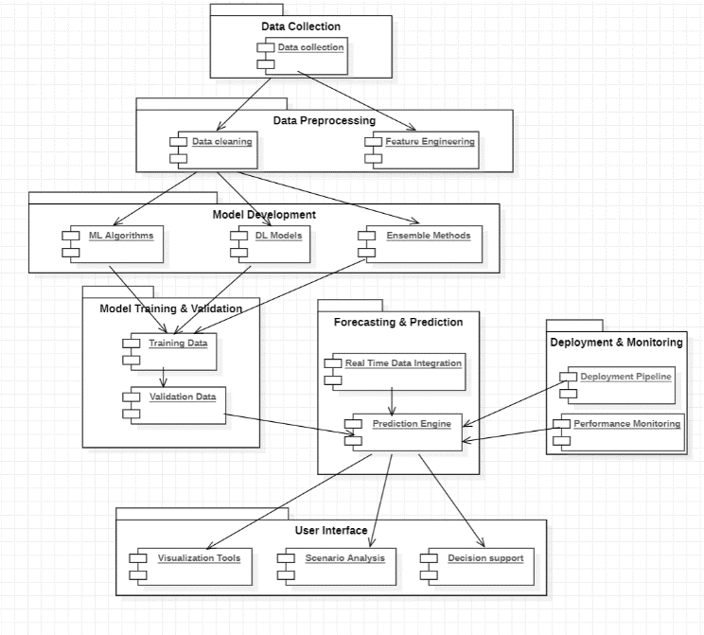

## Data Collection

The Data Collection package is the foundation of the forecasting system. It encompasses the gathering of essential data types required for accurate water demand predictions. This package is crucial for assembling a comprehensive dataset that the forecasting models will use to learn and predict future water demand.

## Data Preprocessing

The Data Preprocessing package involves the preparation and cleaning of raw data collected from various sources, ensuring that the data is in a suitable format for modelling. This process includes data cleaning, which involves removing inconsistencies, handling missing values, and correcting errors in the dataset to ensure data quality. Additionally, feature engineering plays a critical role by selecting, modifying, or creating features (variables) that enhance the performance of machine learning models. Effective data preprocessing is vital for improving the accuracy of the models, as it ensures that the data used is both reliable and relevant.

## Model Development

The Model Development package focuses on building and refining the predictive models used for forecasting water demand:

1. Machine Learning Algorithms: Traditional algorithms like decision trees and support vector machines (SVMs) that are used for initial model development.
2. Deep Learning Models: More advanced models, such as Long Short-Term Memory (LSTM) networks, which are designed to handle complex patterns in time series data.
3. Ensemble Methods: Techniques that combine multiple models to improve prediction accuracy and robustness.

## Model Training & Validation

The Model Training & Validation package deals with the processes of training the models and evaluating their performance:

1. Training Data: The subset of data used to train the models, allowing them to learn patterns and make predictions.

2. Validation Data: A separate subset used to validate the models and assess their accuracy, helping to fine-tune the models and prevent overfitting.

Proper training and validation are essential for ensuring that the models generalize well to new data and provide accurate forecasts.

## Forecasting & Prediction

The Forecasting & Prediction package is responsible for generating and delivering the forecasts:

1. Prediction Engine: The component that uses the trained models to make predictions about future water demand based on the input data.
2. Real-Time Data Integration: Incorporates up-to-date data into the forecasting process to ensure that predictions are current and relevant.

This package enables the system to provide actionable insights into future water needs, supporting decision-making and planning.

## User Interface

The User Interface package offers tools for users to interact with and interpret the forecasting results:

1. Visualization Tools: Provides graphical representations of data and forecasts, making it easier for users to understand trends and patterns.
2. Scenario Analysis: Allows users to explore different scenarios and their potential impacts on water demand.
3. Decision Support: Offers recommendations and insights to help users make informed decisions based on the forecast data.

This package is designed to ensure that the forecasts are accessible and useful to stakeholders, enabling effective planning and management.

## Deployment & Monitoring

The Deployment & Monitoring package focuses on the implementation and ongoing oversight of the forecasting system:

1. Deployment Pipeline: Manages the deployment of the forecasting models and tools into a production environment where they can be used in real-time.
2. Performance Monitoring: Tracks the performance of the system to ensure it operates correctly and meets the expected accuracy and reliability standards.

This package ensures that the system is properly maintained and continues to perform effectively over time.

V. EXPERIMENTAL ANALYSIS

## A. Correlation Coefficient

The correlation matrix is calculated using the Pearson correlation coefficient formula, which measures the linear relationship between two variables. It ranges from -1 to 1, where 1 indicates a perfect positive correlation, -1 a perfect negative correlation, and 0 no correlation.

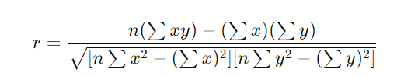

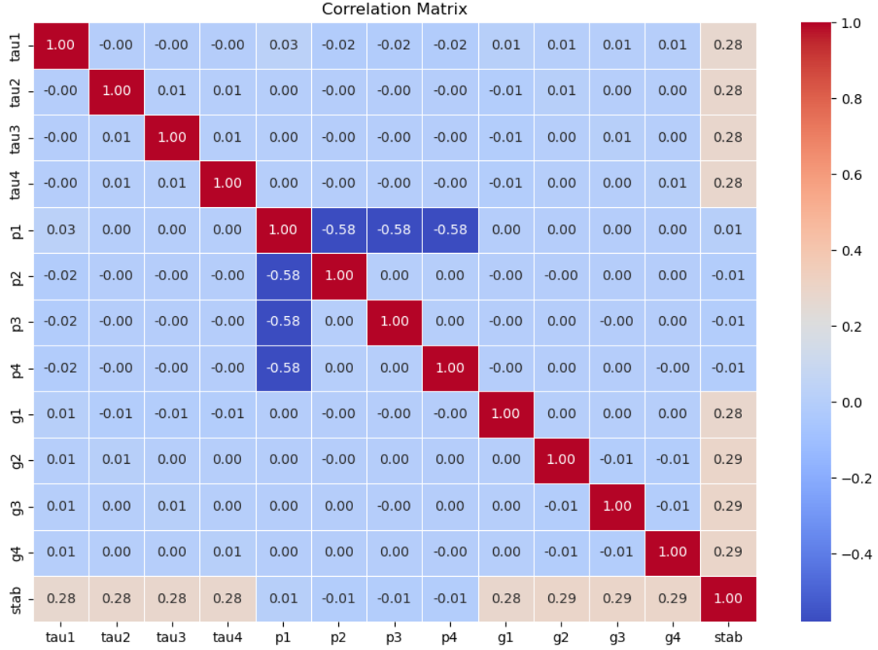

## B. Boxplot

The boxplot visualizes the distribution of data based on these summary statistics, highlighting outliers and the spread of the data.

1. Median (Q2): The middle value of the dataset.
2. First Quartile (Q1): The median of the lower half of the dataset.
3. Third Quartile (Q3): The median of the upper half of the dataset.
4. Interquartile Range (IQR): IQR=Q3−Q1
5. Whiskers: Usually set to:



## C. Accuracy Score

This is the ratio of correctly predicted observations to the total observations. It gives an overall performance metric for the classifier

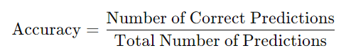

## D. Precision, Recall, F1-Score

These metrics evaluate the performance of a classification model by assessing how well it identifies relevant instances (Precision), how well it finds all relevant instances (Recall), and the balance between Precision and Recall (F1-Score).

1. Precision:

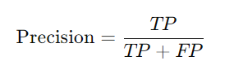

Where TP is True Positives, and FP is False Positives

1. Recall:

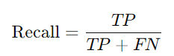

Where FN is False Negatives.

1. F1-Score:



## E. Random Forest Classifier

A Random Forest is an ensemble of Decision Trees. The final prediction is made by averaging or taking the majority vote of individual trees' predictions. .For each decision tree, a prediction is made based on the training data.

The final prediction is based on majority voting or averaging the predictions of individual trees.

Calculated Accuracy: 0.9479

## F. Decision Tree Classifier

A Decision Tree splits the dataset into subsets based on the feature that results in the most significant information gain (typically measured by Gini impurity or entropy).

1. Gini Impurity:

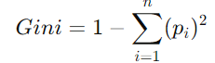

Where pi​ is the probability of a particular class in the node.

1. Entropy:

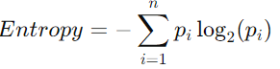

Where pi is the probability of a particular class in the node.

Calculated Accuracy: 0.8958

## Visualization of Classifier Accuracies

This visual comparison helps in understanding which classifier performs better.

1. Bar Plot: The heights of the bars correspond to the accuracy scores of each classifier.
2. Text Annotation: Adds numerical accuracy values above each bar for clarity.

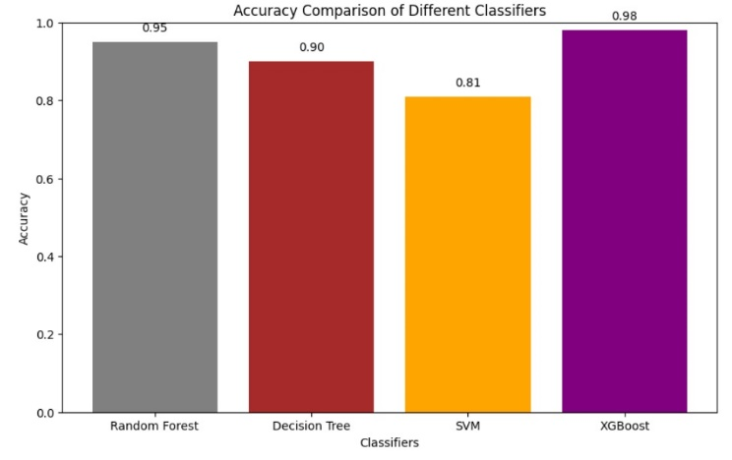

VI. CONCLUSION

The integration of machine learning into smart grid systems offers transformative potential for enhancing efficiency, stability, and predictive maintenance. This project has demonstrated that advanced machine learning techniques can significantly improve grid performance by optimizing energy distribution, detecting and mitigating anomalies, and forecasting equipment failures with greater accuracy.The application of machine learning algorithms enables real-time load forecasting, allowing for more efficient energy management and reduced operational costs. By leveraging models such as deep learning and reinforcement learning, the project has shown that smart grids can better handle the complexities of modern energy demands and the integration of renewable sources. Furthermore, the use of machine learning for anomaly detection enhances grid stability by identifying potential disruptions before they escalate into major issues. Predictive maintenance, powered by machine learning, contributes to the overall reliability of the smart grid by enabling timely interventions and minimizing downtime. This proactive approach not only extends the lifespan of critical infrastructure but also reduces maintenance costs and prevents unexpected failures. In conclusion, the project highlights the significant benefits of incorporating machine learning into smart grid management. It paves the way for more resilient, efficient, and adaptive energy systems, aligning with the growing demand for sustainable and reliable energy solutions. Future research and development in this field will continue to build on these advancements, further optimizing smart grid operations and supporting the transition to a more intelligent and responsive energy infrastructure.

REFERENCES

[1] Zhang, L., Li, X., & Chen, L. (2020). Machine learning-based energy consumption prediction and optimization in smart grids. IEEE Transactions on Smart Grid, 11(3), 2605-2616.

[2] Gupta, P., Kumar, P., & Singh, R. (2021). Enhancing smart grid stability using machine learning techniques. Journal of Electrical Engineering & Technology, 16(2), 839-849.

[3] Zhou, Y., Yang, H., & Liu, W. (2022). A comprehensive review on machine learning applications for smart grid optimization. Energy Reports, 8, 174-195

[4] Zhao, T., Zhang, Z., & Wang, J. (2023). Predictive maintenance for smart grids using deep learning methods. IEEE Transactions on Industrial Informatics, 19(1), 45-54.

[5] Liu, H., Yang, X., & Zhao, Q. (2024). Real-time anomaly detection and response in smart grids using machine learning. Applied Energy, 310, 118389.

[6]. Kim, J., Park, S., & Kim, D. (2020). Data-driven optimization for smart grid operations: A review and future directions. Renewable and Sustainable Energy Reviews, 120, 109645.

[7] Wang, Y., Zhang, J., & Zhao, L. (2021). Advanced machine learning techniques for smart grid load forecasting. Energy, 236, 121452.

[8] Chen, R., Zhang, Y., & Yang, L. (2022). Intelligent algorithms for grid stability enhancement: A survey. Journal of Grid Computing, 20(4), 561-577.

[9] Lee, M., Jeong, H., & Yoon, K. (2023). Smart grid optimization using hybrid machine learning approaches. IEEE Transactions on Power Systems, 38(2), 951-963.

[10] Patel, S., Gupta, V., & Sharma, S. (2024). Machine learning-based fault detection and management in smart grids. Electric Power Systems Research, 210, 1086.